
Lesson 8: Under Pressure
Scratch
VIDEO GAME CREATION
This week: give the enemies you dodge last week actual stakes. An enemy reaching the bottom now costs a life - lose all 3, and "Game Over" appears.
Open your own [YourName]Game project from Lesson 7 - don't start a new one.
Tip: the core exercise needs no new assets - this reuses last week's escape-cleanup code and just gives it a real consequence. For Level 3 sound, use the provided sfx_lifelost.wav and sfx_gameover.wav from the Lesson 8 Assets folder.

Setup
- Open your [YourName]Game project from Lesson 7.
- Create a new variable lives (for all sprites, not "for this sprite only").

Level 1 - Minimal (MVP)
Every enemy that reaches the bottom unshot now costs the player one life, tracked starting at 3. The moment lives reach zero, "Game Over" appears on screen.
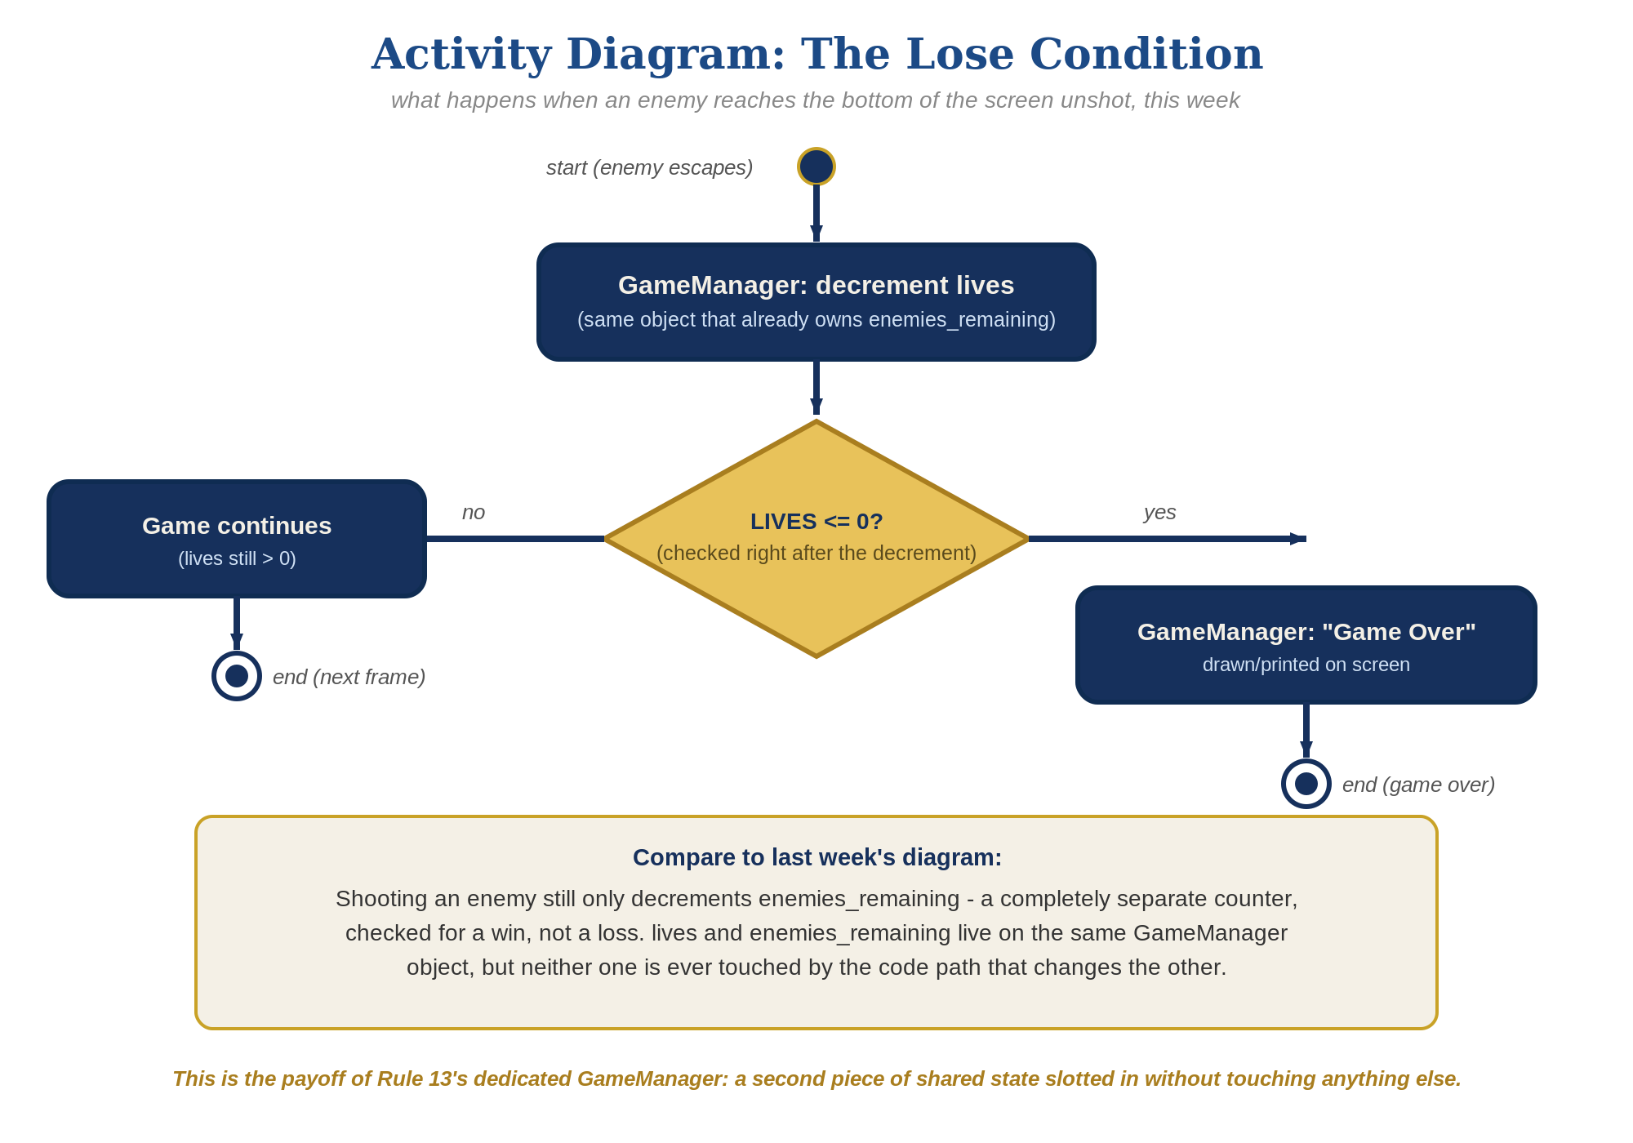
The lose-condition logic behind this week's exercise - the same shape in every engine, whatever the exact code or blocks look like.
- On GameManager's existing "when green flag clicked" script, right where you set enemies_remaining, also add "set lives to 3".
- In the Enemy's forever loop, find the escape branch you built last week (checking y position < -170). Right before "delete this clone", add "broadcast [enemy escaped]" - the Enemy only ever reports what happened, it never counts or decides anything itself.
- On GameManager, add a new script: "when I receive [enemy escaped]" -> "change lives by -1" -> "if lives = 0 then broadcast [game over]" - a direct parallel to its existing "when I receive [enemy hit]" script.
- On the Player sprite, add a new script: "when I receive [game over]" -> "say [Game Over] for 3 seconds".
- Click the stage, then let all 3 lives run out by letting enemies escape unshot - "Game Over" should appear the instant the third one escapes.
Highlighted lines are new this week; everything else is code you already have.
// GameManager (hidden sprite) - existing green flag script:
when green flag clicked
hide
set enemies_remaining to 5
set lives to 3
// Enemy sprite - the escape branch inside its forever loop:
if y position < -170 then
broadcast [enemy escaped]
delete this clone
// GameManager - new script:
when I receive [enemy escaped]
change lives by -1
if lives = 0 then
broadcast [game over]
// Player sprite - new script:
when I receive [game over]
say [Game Over] for 3 seconds

Level 2 - Complete (Alpha/Beta)
Shooting an enemy never costs a life, and letting one escape never counts as a kill - the two counters stay completely independent.
- Shoot an enemy and confirm lives does NOT change - only GameManager's "when I receive [enemy hit]" script, and enemies_remaining, should be involved.
- Let an enemy escape and confirm enemies_remaining does NOT change - only GameManager's "when I receive [enemy escaped]" script, and lives, should be involved.
- Confirm "Game Over" appears exactly once, exactly when lives reaches zero.

Level 3 - Refined (Ready to Publish) - pick any that interest you
- Visual: check the box next to the lives variable in the Variables palette to show a live readout on stage - Scratch's simplest built-in way to display a running number, the same idea as "You Win!" using a basic tool instead of a fancy one.
- Sound: import the provided sfx_gameover.wav and add "start sound" right before the "say" block on the Player's "when I receive [game over]" script. For a life-lost sound too, import sfx_lifelost.wav and add "start sound" to GameManager's "when I receive [enemy escaped]" script, right after "change lives by -1".
- Structure: keep lives, the zero-check, and the game-over broadcast entirely inside GameManager's own "when I receive [enemy escaped]" script - the Enemy sprite only ever reports that it escaped, it never counts or decides anything itself, exactly mirroring how enemy hit already works.

If Something's Wrong
- Lives decreases when you shoot an enemy: confirm the Enemy's touching-Bullet branch only ever broadcasts enemy hit, never enemy escaped, and that GameManager's "when I receive [enemy escaped]" script is the only place lives changes.
- "Game Over" never appears: confirm GameManager's green-flag script actually sets lives to 3 (easy to miss since GameManager is hidden), and that the escape branch actually broadcasts enemy escaped.
- "Game Over" appears multiple times: confirm GameManager has only ONE "when I receive [enemy escaped]" script - a second copy would double-count every escape - and that the check uses "lives = 0" (exact equality), matching the same pattern the win condition used in Lesson 6.

Want More?
Student Resource List > Scratch section, or scratch.mit.edu/ideas

